Car Rental System



**L.J. Institute of Computer Application**

**GROUP NO:**

**07**

**Guided by:**

**Niraj Gautam**

**Himanshu Sharma**

**Project By: -**

**Vinit Koladiya 2020004500210024**

**Chintan Sidhpara 2020004500210068**

**Jay Italiya 2020004500210090**

# **Index**

# **Introduction …**……………………………………………………......4

# Existing System …………………………………………………...5

# Need for the New System …………………………………………….…. 5

# Objective of the New System ………………………………………….... 5

# Problem Definition …………………………………………………….... 5

# Core Components …………………………………………………………6

# Project Profile ………………………………………………………….…6

# Assumptions and Constraints ……………………….……………….……7

# Advantages and Limitations of the Proposed System ………………….…7

# **Requirement Determination & Analysis …**…………………….….8

# Requirement Determination ……………………………………….......….9

# Targeted Users …………………………………………………………….9

# **System Design …**…………………………………………………….10

# Use Case Diagram ……………………………………………………….11

# Data Dictionary ………………………………………………………......19

# **Development …**……………………………………………………...

# Screenshots ………………………………………………………….……

# **Agile Documentation …**………………………………………...…

5.1 Agile Project Charter…………………………………………………….

5.2 Agile Project Plan……………………………………………………….

5.3 Agile Test Plan…………………………………………………………...

# **Conclusion …**………………………………………………………...

# **Bibliography …**………………………………………………………...

**Introduction**

1. Introduction

Car rental system allows individuals to book a self-drive rental car by the day, week, or month. It seamlessly integrates into any platform as it is a web app. Our service enables users to rent cars for traveling in the city or outstation.

# 1.1. Existing System

Currently users book car using the traditional manual system of vehicle reservation

through calling or visiting at store.

# 1.2. Need For the New System

To eliminates the risk of erroneous booking and reduce overall lead time online booking system needed.

# 1.3. Objectives of the New System

The objective of the project is to automate vehicle rental reservation so that the customers do not need to call and spend unnecessary time to reserve a vehicle.

And for the company process become easier to manage bookings and cars on

system rather than manual.

* Customer is only needed to provide Aadhar number instead of submitting

Identity document.

# 1.4. Problem Statement

Customer inquire the company to rent a car. Admin validates the request and ask for security proof. Company asks customer to pay security deposit. After validating the request company can approve or reject car rental request with valid reasons. Then

customer is asked to pay booking amount in advance or after the completion of booking. Security proof is returned to the customer after booking period.

1.5. Core Components

Core components of this projects are

* **User module**
  + Login/Logout.
  + View fleet.
  + View their transaction history.
  + View & manage their account details.
  + View & give testimonial.
  + Request inquiry.
* **Admin module**
  + Login/Logout.
  + Admin can manage fleet.
  + Manage bookings.
  + Manage users.
  + View testimonials.
  + Manage inquires.
* **Visitor module**
  + Register.
  + View fleet.
  + View Testimonials.
  + Request inquiry.

Customers can submit the request, see the status of their request anytime as this system works online.

As the data is saved in database it is easy for admin to generate reports. As it can be done easily in this system.

1.5. Project Profile

* **Name:** Car Rental System
* **Technologies:**
  + Front End: HTML, CSS, JavaScript
  + Back End: Django (Python)
  + Database: MySQL

# 1.7. Assumptions and Constraints

* **Assumptions**
  + All group members have required skills.
  + All of the PC/Laptops are in good conditions.
  + All needed resources will be available.
  + Active internet connection is available to all members.
* **Constraints**
  + Project needs to completed in the span of two months.
  + Group members need to learn Django.
  + We need to take references from websites as local business can’t be visited due to current ongoing pandemic situation.

# 1.8. Advantages and Limitations of Proposed System

* **Advantages**
  + Automated System
  + Saves time and cost
  + The car rental system present instant support to the clients.
  + The car rental system gives an easy booking facility for the clients.
  + The receipts can be easily generated from the rental system.
  + The clients can make advance payment online and bookings for the cars.
* **Limitations**
  + Internet Connectivity
  + Limited Pickup & Drop Points
  + GPS tracking

**Requirement Determination & Analysis**

2.1. Requirement Determination

The existing system that is manual, customers contact the company for booking. Customers submits identity document and pay security deposit and receipt is given to them for their booking. We decided to use Zoom Car as reference. Then our project team determined the system can be built with fulfilled requirements using Django framework.

# 2.2. Targeted Users

* User
* Visitor
* Admin

**System Design**

3.1. Use Case Diagram

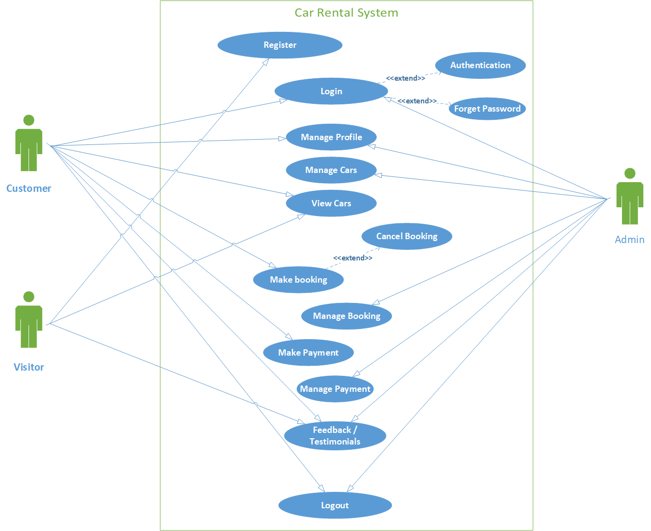

# 3.2. Data Dictionary

**Table Name:** User

**Table Description**: stores the user information.

|  |  |  |  |  |
| --- | --- | --- | --- | --- |
| **Column** | **Type** | **Constraints** | **Description** | **Sample Data** |
| UserId | INT (15) | PIMARY KEY | Id of user | 1 |
| IsAdmin | INT (1) | NOT NULL | Role of user  0: Admin, 1: Not Admin | 1 |
| Username | VARCHAR (45) | NOT NULL,  UNIQUE | Website Name of user | Vinit koladiya |
| FirstName | VARCHAR (45) | - | Name of user | vinit |
| LastName | VARCHAR(45) | - | Last name of user | koladiya |
| Email | VARCHAR(320) | NOT NULL,  UNIQUE | Email of user | [vv@gmail.com](mailto:vv@gmail.com) |
| MobileNo | VARCHAR (13) | UNIQUE | Mobile no of user | +919313795703 |
| Password | VARCHAR (120) | NOT NULL | Password of user account | vinit@123 |
| Address | LONGTEXT | - | Address of user | Kelavnidham, Ahmedabad, Gujarat |

**Table Name:** Booking

|  |  |  |  |  |
| --- | --- | --- | --- | --- |
| **Column** | **Type** | **Constraints** | **Description** | **Sample Data** |
| BookingId | INT (15) | PRIMARY KEY | Id of Booking | 1 |
| SecurityProof | IMAGE | NOT NULL | Id proof of user | booking-security Proof.bin |
| SecurityDepositAmount | DECIMAL (7,2) | NOT NULL | Deposit amount | 2499.00 |
| PickUpDate | DATE | NOT NULL | Car Pick up date | 2021-07-13 |
| PickUpLocation | VARCHAR (128) | NOT NULL | Pick up location | Ahmedabad Railway-station |
| DropDate | DATE | NOT NULL | Car Drop date | 2021-07-18 |
| DropLocation | VARCHAR (128) | NOT NULL | Drop location | Ahmedabad Railway-station |
| UserId | INT (15) | FOREIGN KEY | Reference of user table | 1 |
| PaymentId | INT (15) | FOREIGN KEY | Reference of user payment | 1 |
| CarId | INT (11) | FOREIGN KEY | Id of car | 1 |

**Table Description**: stores the booking details.

**Table Name:** Car

**Table Description**: stores the car details.

|  |  |  |  |  |
| --- | --- | --- | --- | --- |
| **Column** | **Type** | **Constraints** | **Description** | **Sample Data** |
| CarId | INT (11) | PRIMARY KEY | Id of car | 1 |
| PlateNo | VARCHAR (10) | NOT NULL | Plateno of car | GJ05MH2076 |
| Status | INT (1) | NOT NULL | Status of car  0: Available, 1: Booked, 2: Maintenance | 0 |
| ModelId | INT (11) | FOREIGN KEY | Reference of model table | 1 |

**Table Name:** Car Model

**Table Description**: stores the car information.

|  |  |  |  |  |
| --- | --- | --- | --- | --- |
| **Column** | **Type** | **Constraints** | **Desciption** | **Sample Data** |
| ModelId | INT (11) | PRIMARY KEY | Id of model | 1 |
| ModelName | VARCHAR (45) | NOT NULL | Name of model | Hundai i10 |
| ModelType | VARCHAR (45) | NOT NULL | Modeltype of car | Hatchback |
| ModelImage | VARCHAR (100) | NOT NULL | Image of car | image.jpg |
| Price | DECIMAL (7,2) | NOT NULL | Price of car | 1350.00 |

**Table Name:** Testimonial

|  |  |  |  |  |
| --- | --- | --- | --- | --- |
| **Column** | **Type** | **Constraints** | **Description** | **Sample Data** |
| TestimonanialId | INT (15) | PRIMARY KEY | Id of testimonial | 1 |
| Message | LONGTEXT | NOT NULL | Messages of user | Hello World |
| Timestamp | DATETIME | NOT NULL | Date and time of user | 2021-07-09 16:26:42.210756 |
| Rating | INT (1) | NOT NULL,  Rating >= 1 and Rating <= 5 | Rating of user | 5 |
| UserId | INT (15) | FOREIGN KEY | Reference of user table | 1 |

**Table Description**: stores the user information.

**Table Name:** Payment

**Table Description**: stores the payment details.

|  |  |  |  |  |
| --- | --- | --- | --- | --- |
| **Column** | **Type** | **Constraints** | **Description** | **Sample Data** |
| PaymentId | INT (15) | PRIMARY KEY | Id of Payment | 1 |
| Timestamp | DATETIME | NOT NULL | Date and time of user | 2021-07-09 16:26:42.210756 |
| Payment Type | INT (1) | NOT NULL | Type of payment | 1 |
| ReferenceNo | VARCHAR (128) | NOT NULL | Reference number of payments | ipi_1IH5Vo2eZvKYlo2CKPRLvsz3 |

**Table Name:** Contact

**Table Description**: stores the contact data filled by user or visitor.

|  |  |  |  |  |
| --- | --- | --- | --- | --- |
| **Column** | **Type** | **Constraints** | **Description** | **Sample Data** |
| ContactId | INT (15) | PRIMARY KEY | Id of Payment | 1 |
| Name | VARCHAR (45) | NOT NULL | Name of user | vinit |
| Subject | VARCHAR (45) | NOT NULL | Subject of contact | Car inquiry |
| Message | LONGTEXT | NOT NULL | Message for subject | “Hello world!” |
| Email | VARCHAR (320) | NOT NULL | Email of user | vv@gmail.com |